Basic Conceptual Modeling
Ellis S. Cohen
May 2007

The following material has been excerpted from Visual and Textual Entity-Relationship Languages for Conceptual Modeling, and provides an introductory overview of the basic constructs used for conceptual database modeling by the visual ER languages Crow Magnum, UML, and Chen. It also introduces ConText, a textual ER language.

Conceptual models are used for designing systems and applications, especially ones implemented using databases, by identifying relevant classes of entities (e.g. employees, departments, projects, assignments, etc), and determining the relationships between them. This focus on entities and relationships is the reason this kind of modeling is called Entity-Relationship (ER) Modeling.

Most commonly, these models are represented visually, with classes of entities drawn as boxes, and relationships drawn as lines connecting them. There are a variety of visual ER languages, which differ in the notations used to represent different kinds of entity classes and different kinds of relationships.

When designing database-backed systems and applications, the entities and relationships depicted in conceptual models represent data that is meant to be stored persistently in a database. However, conceptual models enable designs to be created at a high level that abstracts away many of the implementation decisions that needs to be made when designing an actual database. Lower-level implementation models of this data are called logical models, or when designed for a relational database, relational models. The process of translating a conceptual model to a relational model (and determining all the implementation details) is called relational mapping. Relational modeling and mapping is outside of the scope of this book.

This book describes versions of the three most widely used visual languages for conceptual ER design, as well as a text-based language. The three visual languages are

Chen is based on Peter Chen's original visual ER language [Chen 76], extended in [Teorey, Yang & Fry 86]. A large number of variants of Chen have been developed over time. Our reference variant comes from [Ramakrishnan & Gehrke 03]; we also heavily use variant notations from [Riccardi 01].

UML is the industry-standard object-oriented visual modeling language. UML class diagrams have unquestionably become the standard for object-oriented visual modeling, and are starting to be used more widely for database modeling as well. However, both Chen and Crow's Foot, a visual ER language whose variants are widely used in database design tools, have features that are more geared to database-oriented conceptual modeling.

Crow Magnum is based on the widely used Crow's Foot notation [Everest 77], but extended with additional notations derived from UML and Chen. It has been developed for this book to provide a coherent visual ER language that is comprehensive and consistent, and which has both practical and pedagogical advantages over other languages used for database-oriented conceptual modeling.

Easy Crow Magnum is a simplified variant of Crow Magnum. While Crow Magnum is primarily meant for presenting the final results of conceptual ER modeling, Easy Crow Magnum is meant to be a working design language. It defines a standard visual vocabulary intended to be used on paper or whiteboards during active design.

This book also introduces ConText, a Conceptual Text-based ER modeling language. It provides a standard text-based language for communicating conceptual designs without requiring drawing, and is also used in conjunction with Crow Magnum for specifying notes and constraints. It comes in two levels -- Brief ConText and Detailed ConText -- that differ in the amount of detail specified for attributes. ConText and Crow Magnum were designed in concert and use consistent notations as much as possible.

Entity Classes

Conceptual modeling is based on the notion of an entity -- an abstraction of the concept of an object (from object-based modeling) or a tuple (from database design), or more generally, a person, place, or thing.

A single specific entity is called an entity instance. For example, an Employee instance identifies a specific employee, which might have some group of attributes, such as an employee number, an employee name, an address, etc.

An entity class, on the other hand, represents an abstract concept, and instances of that entity class are specific individual representatives of that concept. For example, the entity class Employee represents, in a general or abstract way, someone who is employed by an organization, as opposed to Employee instances, which represent specific employees.

An entity class is generally (i.e. in Chen, UML, and Crow Magnum) drawn as a box containing its name. In Easy Crow Magnum, the box outline is not shown.

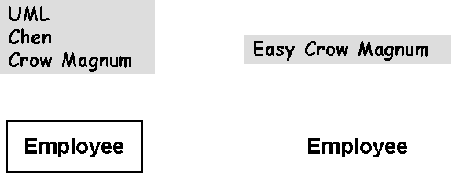
Entity Classes with Attributes

An entity class defines a group of attributes, and all instances of that entity class have those attributes. For example, an Employee entity class may define the attributes empno, ename, and address, corresponding to an employee's employee number, employee name, and home address. These are attributes that each employee may have.

Conceptual models may display these attributes as part of the entity class, depending upon the degree of detail needed in the diagram

Crow Magnum lists an entity's attributes below the entity class box, about 2/3 of the way across the box. (Of course, in Easy Crow Magnum, the box is not shown)
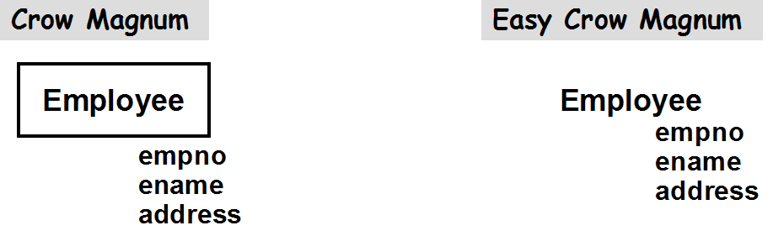

Chen places each attribute in an ellipse connected to its parent entity class. UML lists attributes below the entity class name, but includes them in the box with the entity class name, separated by a horizontal line.
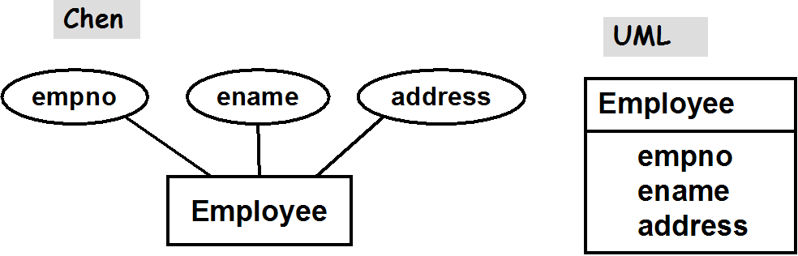

Attributes typically have relatively simple values (numbers, strings, dates). The conceptual model does support more complex attributes that can hold structured data (composite attributes), or collections of values (multi-valued attributes). Composite and multi-valued attributes should generally be used carefully sparingly; they are discussed in more detail later.

Primary Key Attributes

A primary key attribute is an attribute of an entity class whose value uniquely identifies a single instance of that entity class. Primary key attributes are underlined in the Crow Magnums and in Chen.
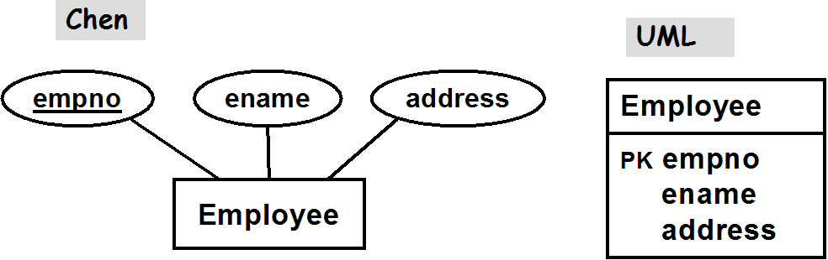
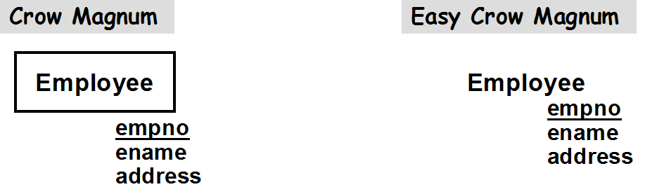

UML, meant primarily as an object-oriented modeling language for program design (rather than database design) does not have a built-in notion of primary key. However, UML allows icons to identify key properties of attributes. We use the PK icon (part of Rational's UML profile for Database Design) to identify the primary key attributes.

UML also supports semantic extensions through stereotypes, which are enclosed in guillemets ('«' and '»'), so we could instead have identified primary key attributes by preceding the attribute name with the «PK» stereotype. Finally, some UML designers enclose the PK is curly braces (used to represent properties, discussed in more detail below), and place them following the primary key attribute(s), such as in empno {PK}.

Conceptual models can also be described textually. This example above can be written in Brief ConText (our lightweight textual representation for conceptual modeling) as

Employee( empno, ename, address )

Entity classes are not required to have primary keys (though this is common and encouraged). Primary keys can be added later as part of relational mapping, the mapping of an abstract conceptual model to an implementation-specific relational model.

Entity Classes shown only with Primary Key Attributes

The amount of detail shown in a conceptual model often depends on how it is to be used -- e.g. for communication between team members vs as detailed documentation. Showing all attributes of an entity class is often unnecessary or makes diagrams too busy.

In the Crow Magnums, it commonly to draw entity classes showing just their primary keys (and discriminators, discussed later). Chen and UML can also limit attributes to primary keys, though this is not as common.
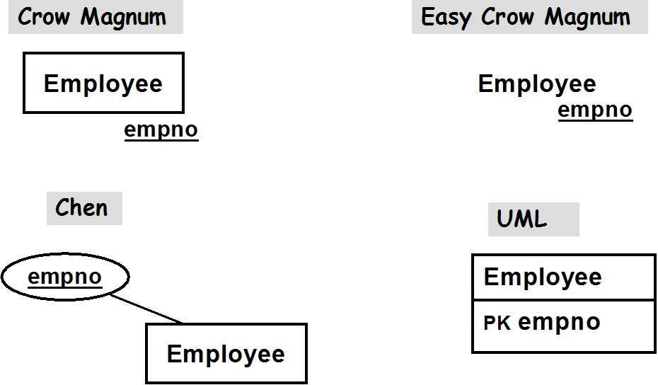
In ConText, all attributes of an entity class are always listed.

Entity Attributes

An entity attributes is an attribute whose value holds or identifies an entity instance (e.g. by holding its primary key). For example, suppose we defined a Dept class as

Dept( deptno, dname )

Then we might think about defining the Employee class as

Employee( empno, ename, address, deptno )

That is, in addition to an empno, an ename, and an address, each employee might have a deptno attribute which identifies the Dept the employee works for. The deptno attribute is called an entity attribute, since its value identifies a specific Dept -- i.e. an entity instance.

Entity attributes are used in logical models, in fact, in relational models, they are known as foreign keys. However. entity attributes, whose values (e.g. deptno) identify an entity instance (e.g. some specific Dept), are not allowed in ER models. Such entity attributes must instead be replaced by relationships, described below.

1:M (one-to-many) Relationships

Entities may be related to one another. For example, consider an Employee and a Dept entity class, and the "works for" relation, which characterizes which employee works for which dept. We can use instance diagrams to depict some examples:
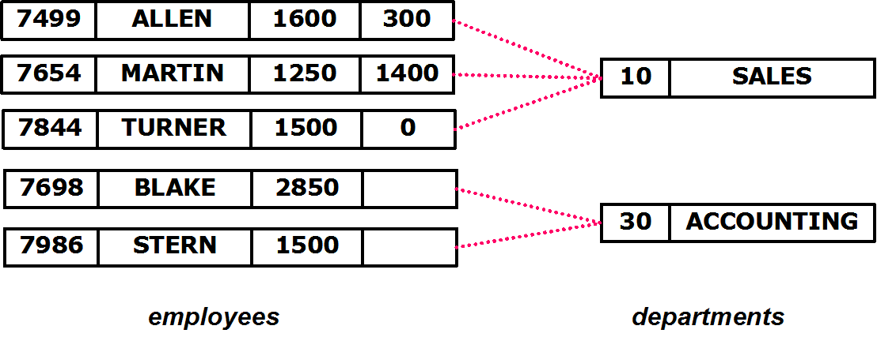

Note: We use instance diagrams just to show examples of entity instances and how they are related. Instance diagrams should not be confused with ER diagrams, which represent entity classes. UML's object diagrams, which are somewhat similar visually, play the same role as instance diagrams.

The instance diagram above shows 5 employee, each with an employee #, an employee name, a salary, and a commission; and 2 departments, each with a department # and name. The dotted lines indicate which employee works for which dept.

In ER models, relationships are represented as links between entity classes. In the Crow Magnums, the the characterization of the relationship (e.g. "works for") is placed along the line.

The crow's foot indicates (as the instance diagram demonstrates) that many employees are "gathered together" and associated with a single department, or equivalently, that one department "spreads out" to be associated with many employees.

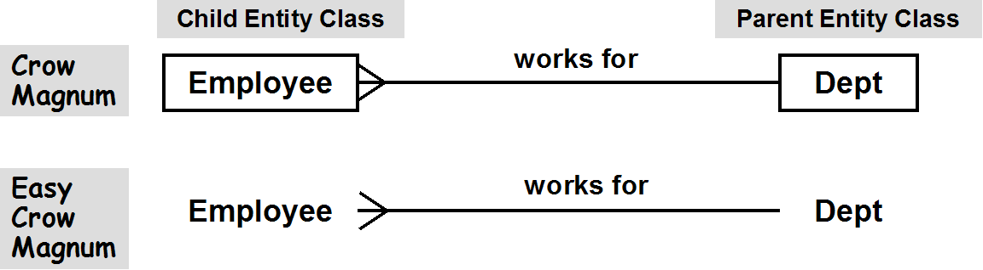
In a one-to-many relationships, where many instances of one class are related to a single instance of the other class, we call the "many" side (e.g. Employee) the child entity class, and the "one" side (e.g. Dept) the parent entity class.

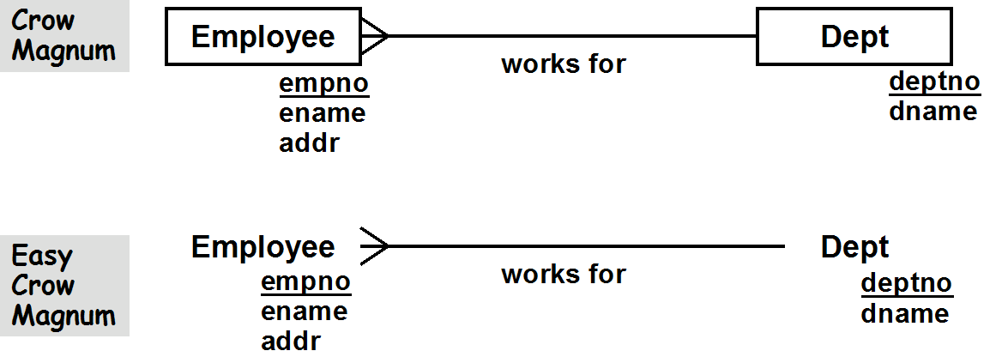
Attributes (either all attributes, or just the primary keys) can be shown in diagrams along with relationships, as in

In ConText, a description of a 1:M relationship such as the ones shown above is written as

(*) Employee works for Dept

which indicates that an employee work for (at most) a single department. Its cardinality indicator (*) indicates that any number of employees can work for a department.

ConText also distinguishes between a relationship characterization such as "enrolled in", and an optional relationship name which uniquely identifies a relationship in an ER model (independently of the names of the related entity classes). ConText strongly encourages using a relationship name, which must be unique, to label relationship descriptions, as in

WorksFor: (*) Employee works for Dept

In the Crow Magnums, the relationship name can be shown instead pf the relationship characterization, although the latter is preferred. However, the following is allowed:

UML's uses the term association for a relationship and also shows relationship characterizations. Instead of the crow's foot, it uses the multiplicity indicator * to mean that a department can have any number (i.e. *) of employees who work for it, similar to the notation used in ConText. It also explicitly indicates (with the multiplicity indicator 0..1) that an employee works for between 0 and 1 departments -- i.e. at most a single department.

A 1:M relationship imposes what is called a key constraint between the child class and the parent class – every instance of the child class is associated with at most one instance of the parent class. In this case, every employee works for at most one department. This is a constraint, since it constrains what the system allows. In particular, it does not allow an employee to work for more than one department.

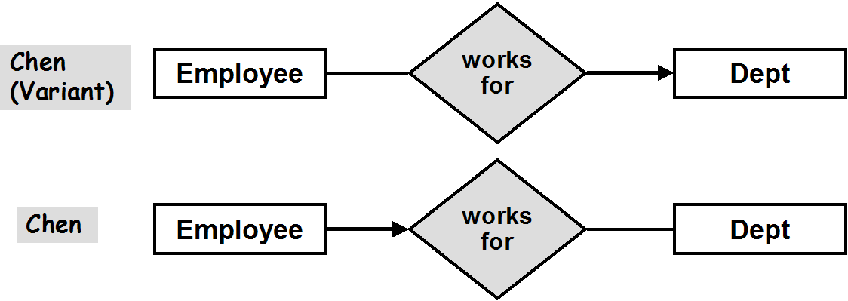
Chen's visual language is designed to emphasize the key constraint, by drawing an arrow from the Employee class to the Dept to emphasize this, meaning, if you know the identity of an employee, you know the identity of the department (possibly none, but at most one) that they work for.

Chen places the relationship characterization in a diamond interposed between the two entity classes, and different variants of Chen show the arrow in different places. Our reference variant draws the arrow from the child entity class (e.g. Employee) to the relationship diamond (e.g. works for). Other Chen variants (which are actually more commonly used) draw the arrow from the relationship diamond to the parent entity class. We'll talk about this language design choice again when we discuss weak entity classes and n-ary relationships.

Entity Attributes and 1:M Relationships
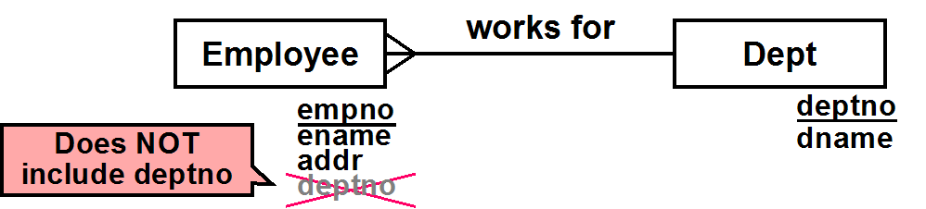

The WorksFor relationship between Employee and Dept is represented visually by the line which connects them. As we've noted, a 1:M relationship corresponds to a key constraint -- that is, associated with each employee, there is (at most) a single department. So we might be tempted to add a deptno attribute to Employee which identifies that department. But that would be redundant and incorrect.

A deptno attribute would act as an entity attribute, an attribute whose value holds or identifies some other entity -- in this case its value identifies a department entity. Entity attributes whose values identify other entities are not allowed in conceptual models. Because Employee holds a deptno, it establishes an association between an employee and the department identified by its deptno. But in conceptual models, associations must be explicitly represented by relationships. And since we've already done that with the WorksFor relationship, deptno is not only disallowed, but would be completely redundant.

Relationship Direction

In the Crow Magnums, relationship characterizations are read left-to-right (assuming the text is in a language read left-to-right), and top-to-bottom. Switching the order often requires switching the relationship characterization between active and passive voice. For example, in ConText

WorksFor: (*) Employee works for Dept

can be written instead as

WorksFor: Dept contains (*) Employee

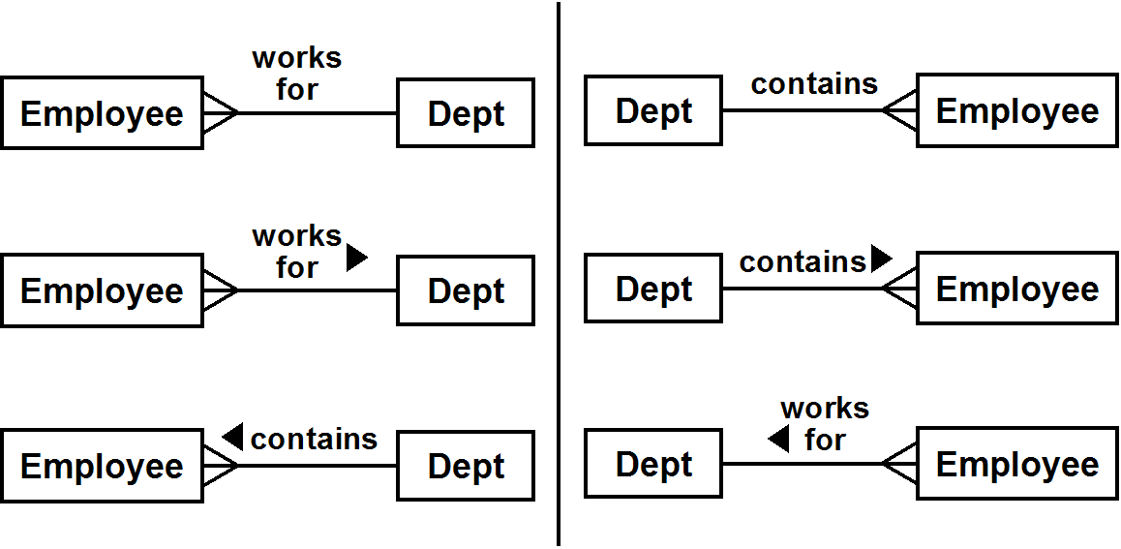
UML and the Crow Magnums use an arrow head to explicitly indicate the reading direction.

The Crow Magnums allow both relationship characterizations to be shown with their respective arrowheads at the same time, though this is uncommon.

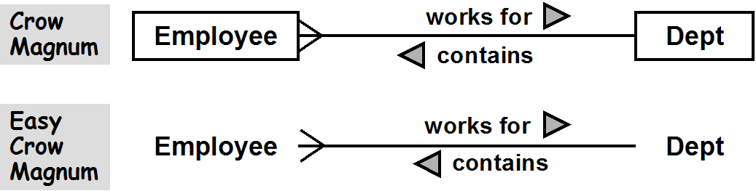
Chen allows the reverse characterization to be displayed below and to the right (assuming a R-to-L language) of the diamond.

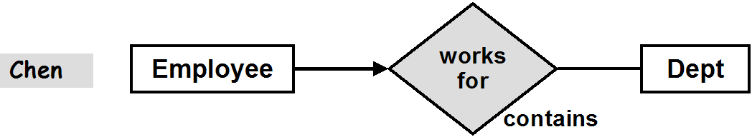
1:1 (one-to-one) Relationships

1:1 Relationships are similar to 1:M relationships, except that cardinalities greater than one are not allowed on either side of the relationship. A good example is a relationship between employees and desks, where an employee can be assigned to at most one desk, and a desk can have at most one employee assigned to it.

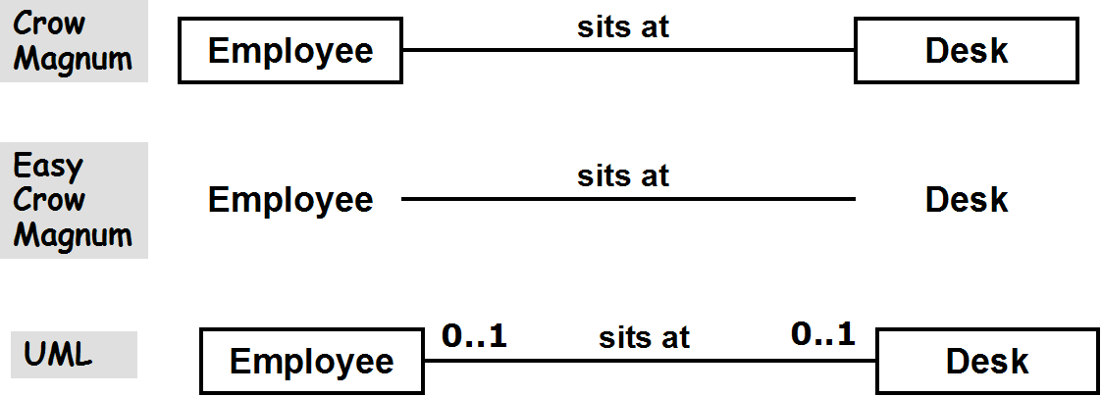

In ConText, this is written as

DeskAssignment: Employee sits at Desk

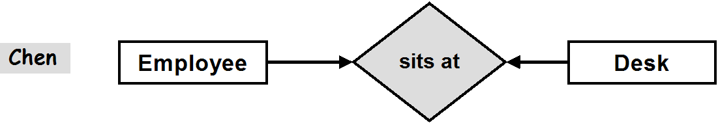
In Chen, a 1:1 relationship is identified by arrows representing key constraints on both sides of the diamond. In the example below, if you know the employee, you know the desk (if any) the employee sits at, and if you know the desk, you know the employee (if any) who sits at it.

M:N (many-to-many) Relationships

M:N Relationships are similar to 1:M relationships, except that cardinalities greater than one are allowed on both sides of the relationship. A good example is a relationship between employees and projects, where an employee can be assigned to many projects, and a project can have many employees assigned to it, as depcietd by the instance diagram below.
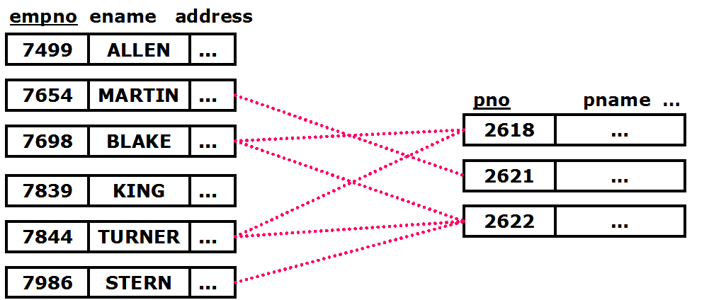

This is represented in the Crow Magnums and UML as you might expect:

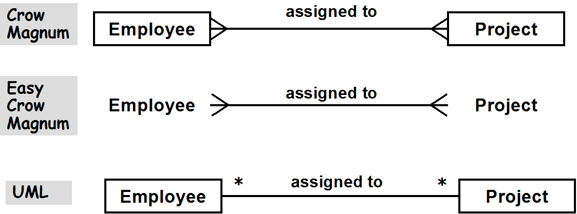
In ConText, this can be written as

Assignment: (*) Employee assigned to (*) Project

In Chen, the lack of arrows indicating key constraints distinguishes an M:N relationship. In the example below, there are no key constraints because knowing an employee can not identify one single project the employee works on, and knowing a project can not identify one single employee who works on the project.
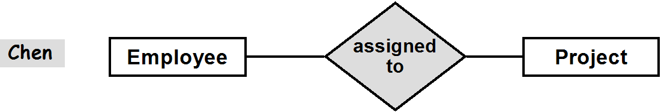
Mandatory Child Participation

Consider the 1:M relationship between employees and departments. An employee works for at most one department, but must an employee work for a department at all, or can a company have employees who are unassigned to any department? Similarly, a department may have any number of employees, but is a department allowed to exist if it doesn't have any employees? These are issues of mandatory participation.

If an employee is mandated to work for a department, then in the Crow Magnums, a bar is placed at the Dept end of the link. The bar looks a bit like a "1", indicating the mandatory participation constraint: an employee must work for exactly 1 department (i.e. working for 0 departments is not an option)

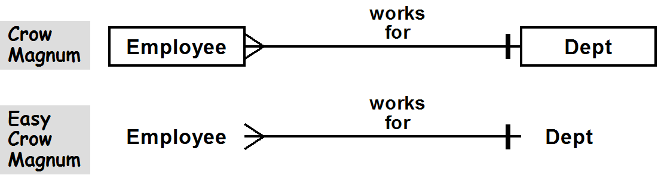
ConText represents mandatory participation using the explicit cardinality indicator (1) , meaning exactly one Dept is associated with an Employee, or (!), which means the same thing

WorksFor: (*) Employee works for (1) Dept
or
WorksFor: (*) Employee works for (!) Dept

In UML, a multiplicity indicator of 1 is used.

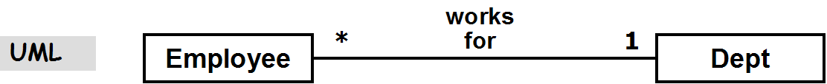
Chen's point of view is that the mandate is associated with the child – the employee. That is, the employee is mandated to work in a department (rather than being allowed to be unassigned). Chen's terminology is that the employee is required to have mandatory participation in the "works in" relationship, by being required to work for a department, and our reference variant indicates this by thickening the link between the child entity class (e.g. Employee) and the relationship ("works for") in which it must participate. Other Chen variants uses a double line in the same place, but remember that the key constraint is placed on the other side of the relationship diamond. In effect, our reference Chen variant is child-focused: the visual combination of the key and participation constraint in the reference variant indicates that an employee (a child instance) both determines its department, and is mandated to have a department.

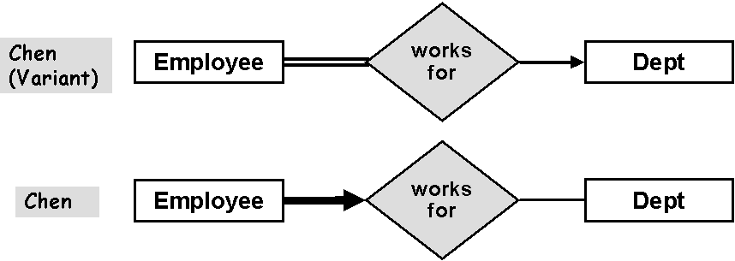
Mandatory child participation impacts the deletion of parents. If an employee must be assigned to a department, then deletion of a department which has employees cannot leave those employees unassigned. Either the deletion of the department is disallowed, or the employees must be moved to another department or deleted themselves.

Mandatory child participation also impacts the creation of children; when a new employee is created, it must immediately be assigned to a department.

Mandatory Parent Participation

Mandatory participation can be applied to other side of the relationship as well. If a department is required to have at least one employee, then in the Crow Magnums, a bar is placed next to the crow's foot at the Employee end of the link, representing the mandatory participation constraint that a department must have "1" or more employees (i.e. departments with 0 employees are not an option).

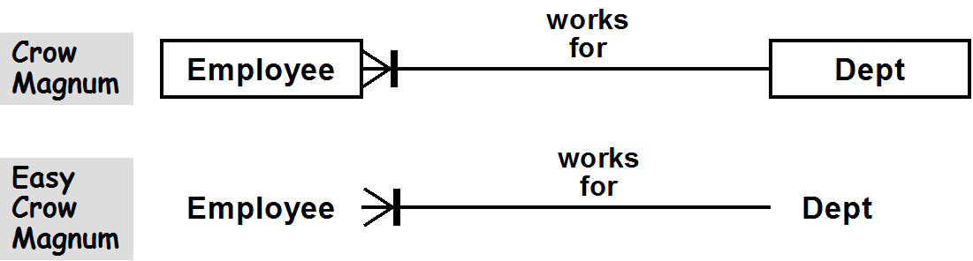
ConText uses the cardinality indication (1..*) (meaning any number of employees, but at least one):

WorksFor: (1..*) Employee works for Dept
or
WorksFor: Dept has (1..*) Employee

In UML, a multiplicity of 1..* is placed next to the Employee end of the association

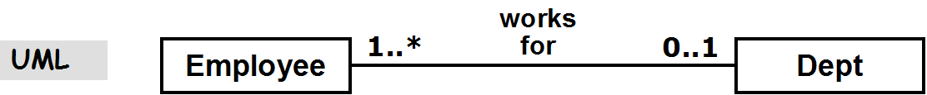
From Chen's point of view, the mandate is on the parent – the department, and our reference variant thickens the line between Dept and the "works for" relationship, indicating that Dept must have mandatory participation in the "works for" relationship, by being mandated to have at least one employee work for it (the Chen variant, in which the key constraint is placed on the other side of the relationship diamond, doubles the line instead of thickening it). As we noted above, our reference Chen variant is child-focused, while other Chen variants are parent-focused: the visual combination of the key and participation constraint in these other variants indicates that a department (a parent instance) is both determined by an employee, and is mandated to have at least one of them.

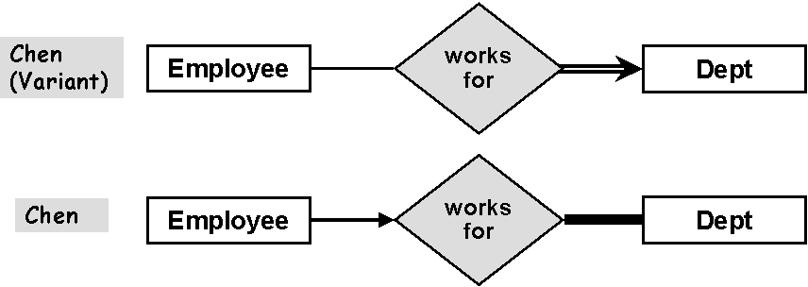
Mandatory parent participation impacts the creation of parents. If a department must have employees, then when a new department is created, one or more employees must immediately be assigned to it.

Mandatory parent participation also impacts the deletion of children. Either the removal of the last employee in a department cannot be allowed, or it must result in moving another employee into the department, or deleting the department.

Reflexive Relationships

Reflexive relationships are relationships among entities of the same class. The manages relationship, which indicates that employees can manage other employees, is a good example:

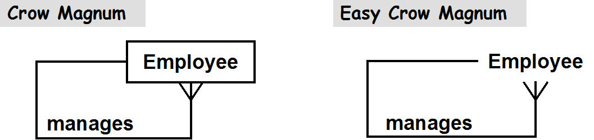
Typically, 1:M reflexive relationships represent a tree of entity instances. That is, the top manager (e.g. a president) manages a set of employees, each of whom manage other employees, etc.), as the instance diagram of employees below indicates

